D.Y. PATIL COLLEGE OF ENGINEERING & TECHNOLOGY, KOLHAPUR
(An Autonomous Institute)


DEPARTMENT OF CSE (DATA SCIENCE)

A
Project Report
on
“Blockchain Wildlife Conservation”
Submitted by
Name | Roll No.
Samarth.A.S. Patil | 74
Samarth.P. Maske | 141

Under the guidance of
Prof. DR. G. V. Patil
HOD

Third Year B. Tech. CSE (Data Science)
Academic Year 2025-26
D. Y. PATIL COLLEGE OF ENGINEERING & TECHNOLOGY, KOLHAPUR
(An Autonomous Institute)


DEPARTMENT OF CSE (DATA SCIENCE)
CERTIFICATE

Roll No. | Unique ID | Student Name
74 | EN | Samarth Patil
141 | EN | Samarth Maske
This is to certify that,

have successfully completed the project work entitled,
“Blockchain Wildlife Conservation”
In partial fulfilment for the curriculum of Final Year B. Tech. CSE (Data Science). This is the record of their work carried out during academic year 2024-2025.

Date: 16/5/26 Place: Kolhapur

Prof. DR. G. V. Patil | Prof. DR. G. V. Patil | Prof. DR. S. D. Chede
Project Guide | HOD | Principal

INDEX
Sr. No. | Topic | Page Number
1. | Abstract | 1
2. | Introduction  - Need of Work  - Proposed System | 2
3. | Problem Statement & Objectives | 4
4. | Requirement Analysis  - Hardware Requirements  - Software Requirements  - Libraries Used | 6  7  8
5. | System Design & Implementation  - System Architecture  - Implementation Details | 10  11
6. | Result (Sequential Screen Shots) | 12
7. | Conclusion | 14
8. | References | 15

Animal Wildlife Conservation System
Project Report

1. Abstract
The rapid decline in wildlife populations and habitat destruction has become a major global concern. Conservation agencies and forest departments require secure, transparent, and efficient systems to record wildlife conservation activities and maintain historical records without the risk of data tampering. Traditional systems generally rely on centralized databases that are vulnerable to unauthorized modifications, data loss, and integrity issues.
The “Animal Wildlife Conservation System” is a blockchain-inspired web application developed using PHP, MySQL, HTML, CSS, and JavaScript. The system is designed to securely record conservation-related activities such as animal rescue operations, habitat restoration efforts, wildlife monitoring, and rehabilitation processes. Each submitted conservation report is converted into a blockchain block containing a cryptographic hash, timestamp, previous hash value, and conservation details. This creates an immutable ledger structure where records are securely linked together.
The proposed system provides features such as conservation report submission, mining pending reports into blocks, blockchain verification, and on-chain ledger visualization. The application improves transparency, ensures data integrity, and helps maintain reliable conservation records. The system can be effectively utilized by forest officers, wildlife organizations, NGOs, and conservation authorities for secure wildlife data management.
The project demonstrates the integration of blockchain concepts into environmental conservation management and provides a scalable foundation for future enhancements such as GPS integration, image uploads, cloud deployment, and real blockchain implementation.

2. Introduction
Wildlife conservation plays a vital role in maintaining ecological balance and biodiversity. Increasing incidents of illegal poaching, habitat destruction, climate change, and environmental pollution have created a serious threat to endangered species across the world. Conservation organizations and government agencies continuously perform rescue operations, habitat restoration activities, and wildlife monitoring programs to protect animal species and preserve natural ecosystems.
Managing wildlife conservation records manually or using traditional database systems often results in issues such as data redundancy, unauthorized modifications, lack of transparency, and poor traceability. Since conservation data is highly sensitive and valuable for research, policy-making, and environmental planning, maintaining data integrity and security becomes extremely important.
Blockchain technology offers a modern solution to these challenges. Blockchain provides decentralization, immutability, transparency, and secure data storage through cryptographic hashing techniques. Inspired by these concepts, the proposed “Animal Wildlife Conservation System” uses a blockchain-based ledger mechanism to securely store conservation records.
The system allows authorized users such as forest officers or NGO personnel to submit wildlife conservation reports through a user-friendly web interface. Reports are stored as pending entries and later mined into blockchain blocks. Each block is connected with the previous block using hash values, ensuring that no record can be altered without affecting the entire chain.
The project combines modern web technologies with blockchain principles to create a reliable conservation management system. It provides secure record keeping, easy report management, and blockchain validation functionality for ensuring ledger authenticity.

a. Need of Work
Wildlife conservation organizations require reliable systems for maintaining accurate records of conservation activities. Existing manual systems and traditional centralized databases suffer from several limitations including:
- Risk of unauthorized data modification
- Lack of transparency in record management
- Difficulty in maintaining historical records
- Absence of secure verification mechanisms
- Data duplication and inconsistency
- Limited traceability of conservation actions
In many cases, wildlife conservation data is distributed across multiple departments and organizations, making coordination and data verification difficult. Sensitive information regarding endangered species, rescue operations, and habitat restoration efforts must be securely stored to avoid manipulation or loss.
Blockchain technology introduces features such as immutability, cryptographic security, and transparent record management. Integrating blockchain concepts into wildlife conservation can help create secure and tamper-resistant conservation ledgers.
Therefore, there is a strong need for a digital conservation management system that:
- Maintains secure wildlife records
- Prevents unauthorized modifications
- Provides transparent tracking of conservation activities
- Ensures data integrity using cryptographic hashing
- Supports efficient report management
- Maintains historical conservation data
The proposed Animal Wildlife Conservation System fulfills these requirements by implementing a blockchain-inspired ledger for wildlife conservation records.

b. Proposed System
The proposed system is a web-based blockchain-enabled wildlife conservation management application developed using PHP and MySQL. The system enables forest officers, NGOs, and conservation authorities to securely record and manage conservation activities.
The application consists of the following major modules:
1. Conservation Report Submission Module
This module allows users to submit wildlife conservation reports by entering details such as:
- Species name
- Location
- Habitat information
- Conservation action type
- Notes and observations
- Reporter details
Submitted reports are initially stored as pending records.
2. Blockchain Mining Module
Pending reports are processed and converted into blockchain blocks. During mining:
- A timestamp is generated
- Previous hash is retrieved
- Current block hash is generated using SHA hashing
- Block data is linked securely to the blockchain
3. Ledger Verification Module
The system verifies blockchain integrity by checking:
- Previous hash matching
- Block consistency
- Hash authenticity
- Ledger validity
4. On-Chain Conservation Ledger
All mined blocks are displayed in a blockchain ledger format showing:
- Block number
- Current hash
- Previous hash
- Timestamp
- Conservation report details
The proposed system ensures transparency, improves security, and minimizes the risk of data tampering.

3. Problem Statement & Objectives
Problem Statement
Wildlife conservation departments and organizations generate a large amount of sensitive conservation data related to animal rescue, habitat restoration, wildlife monitoring, and rehabilitation activities. Traditional systems used for maintaining these records are often centralized and vulnerable to data tampering, unauthorized modifications, poor transparency, and integrity issues.
There is a need for a secure and transparent conservation management system capable of maintaining immutable wildlife records while ensuring authenticity, traceability, and efficient data management.
The proposed system aims to solve these issues using blockchain-inspired data storage techniques.

Objectives
The major objectives of the project are:
- To develop a secure wildlife conservation management system.
- To implement blockchain concepts for maintaining immutable conservation records.
- To provide a user-friendly interface for submitting conservation reports.
- To generate cryptographic hashes for ensuring data integrity.
- To maintain a transparent and verifiable conservation ledger.
- To reduce risks associated with unauthorized data modification.
- To improve management and traceability of conservation activities.
- To provide blockchain verification functionality for validating ledger authenticity.
- To create a scalable platform for future conservation technologies.

4. Requirement Analysis
Requirement analysis is an important phase in software development that identifies the resources, technologies, and functionalities required for successful implementation of the system.

a. Hardware Requirements
The following hardware configuration is sufficient for developing and running the proposed system:
Component | Specification
Processor | Intel Core i3 or above
RAM | Minimum 4 GB
Storage | 500 GB HDD / SSD
Monitor | 1366 × 768 Resolution
Keyboard | Standard Keyboard
Mouse | Optical Mouse
Internet | Required for research and updates

b. Software Requirements
Software | Description
Operating System | Windows 10 / Windows 11
Frontend Technologies | HTML, CSS, JavaScript
Backend Technology | PHP
Database | MySQL
Server Environment | XAMPP
Browser | Google Chrome / Microsoft Edge
Code Editor | Visual Studio Code

c. Libraries Used
The project utilizes the following libraries and technologies:
Library / Technology | Purpose
HTML5 | Structure of web pages
CSS3 | Styling and responsive UI
JavaScript | Client-side functionality
PHP | Backend processing
MySQL | Database management
XAMPP | Local server environment
SHA Hashing Functions | Blockchain hash generation
Description of Libraries Used
HTML5
Used for creating the structure and layout of the web pages.
CSS3
Used for designing attractive user interfaces and improving the visual appearance of the application.
JavaScript
Used for implementing dynamic behavior and client-side interactions.
PHP
Used as the backend scripting language for processing form data, generating blockchain blocks, and managing database operations.
MySQL
Used for storing pending reports and blockchain ledger records.
XAMPP
Provides Apache server and MySQL database support for local project execution.
SHA Hashing
Used to generate unique cryptographic hash values for each blockchain block.

5. System Design & Implementation
The “Animal Wildlife Conservation System” is designed as a secure web-based application that integrates blockchain concepts with wildlife conservation management. The system follows a modular architecture where different components work together to ensure secure report submission, blockchain-based storage, ledger verification, and transparent conservation record management.
The application is developed using PHP, MySQL, HTML, CSS, and JavaScript. The system focuses on maintaining data integrity, preventing unauthorized modifications, and providing a user-friendly environment for forest officers and conservation organizations.

a. System Architecture
The system follows a three-tier architecture consisting of the Presentation Layer, Application Layer, and Data Layer. Blockchain functionality is integrated into the application layer for secure record processing.
1. Presentation Layer
The presentation layer acts as the user interface of the system. It allows users to interact with the application through web pages and forms.
Functions:
- Submit conservation reports
- View blockchain ledger
- Verify blockchain integrity
- Access dashboard controls
Technologies Used:
- HTML
- CSS
- JavaScript
This layer provides a responsive and user-friendly interface for smooth interaction.

2. Application Layer
The application layer contains the business logic and blockchain processing functionalities.
Main Responsibilities:
- Report validation
- Block creation
- Hash generation
- Mining pending reports
- Ledger verification
- Data processing
Technology Used:
- PHP
This layer processes user requests and performs blockchain-related operations securely.

3. Blockchain Layer
The blockchain layer maintains immutable conservation records using cryptographic hashing techniques.
Functions:
- Create blockchain blocks
- Generate SHA-based hashes
- Link previous hash values
- Verify blockchain integrity
- Maintain ledger consistency
Each block is connected with the previous block to prevent data tampering.

4. Data Layer
The data layer stores all reports and blockchain records in the database.
Database Stores:
- Pending conservation reports
- Mined blockchain blocks
- User details
- System logs
Technology Used:
- MySQL
The database ensures organized storage and efficient retrieval of conservation data.

Working Flow of the System
- User submits a conservation report.
- Report is stored as a pending entry.
- Mining process converts pending reports into blockchain blocks.
- Current hash and previous hash values are generated.
- Block is stored in the blockchain ledger.
- Verification module checks blockchain integrity.
- Ledger displays all validated blocks.

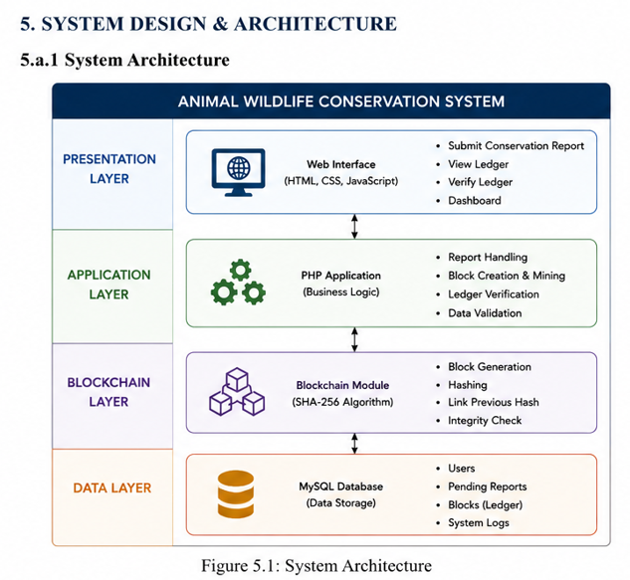

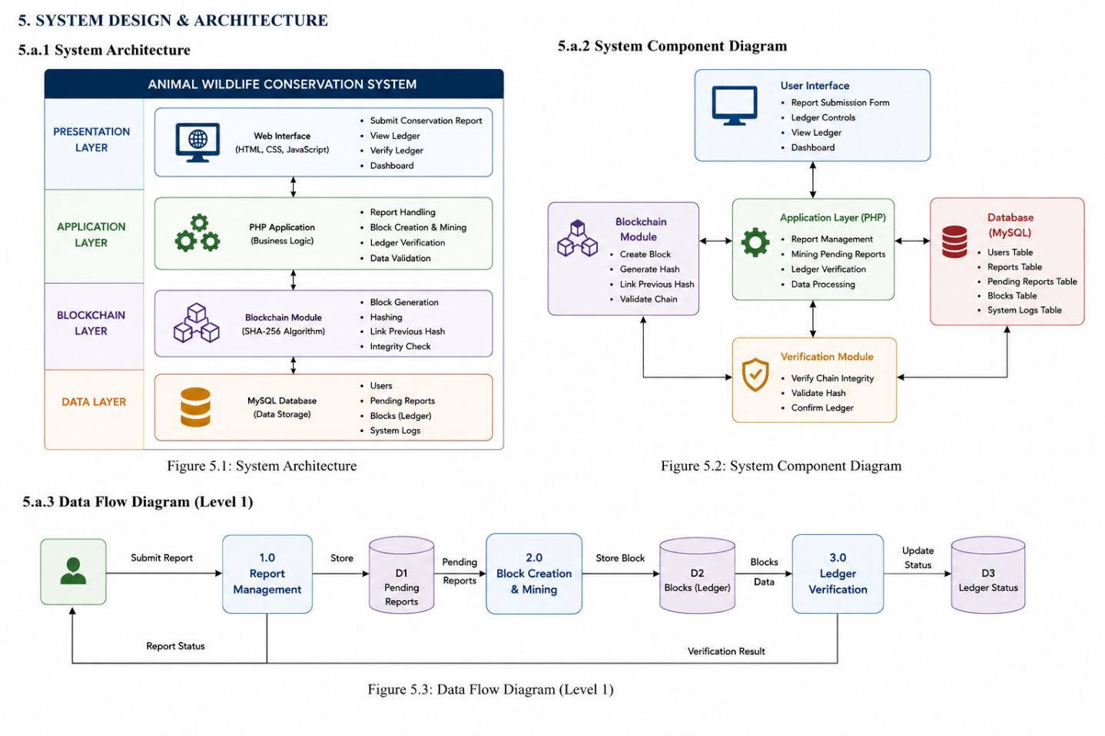

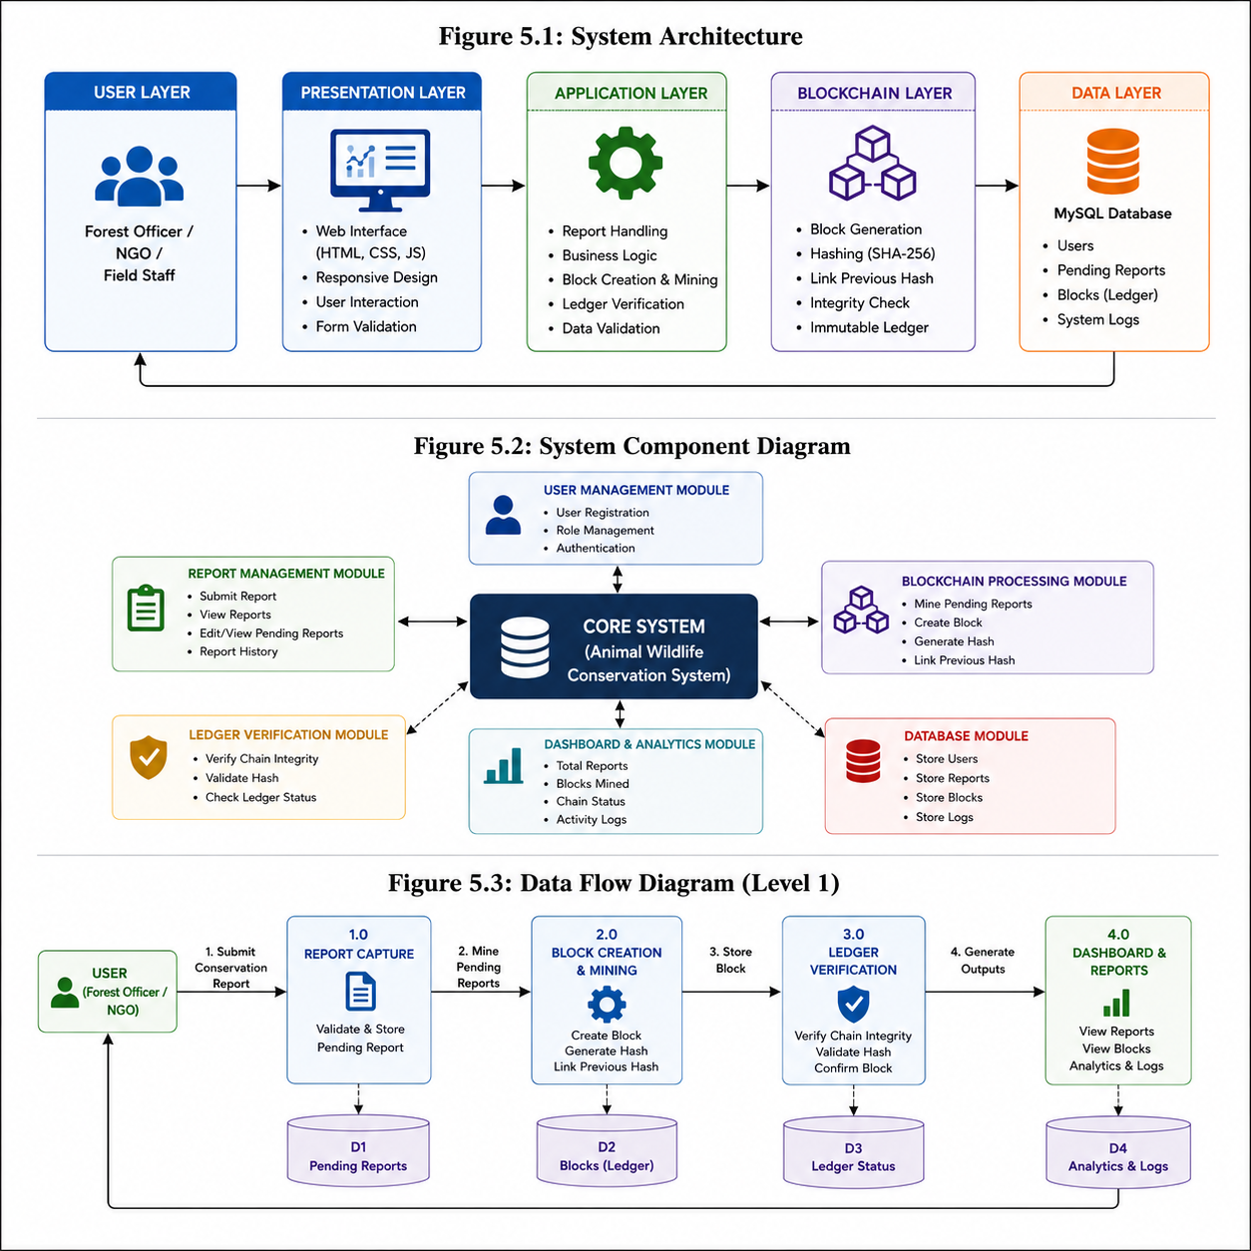

b. Implementation Details
The implementation of the system focuses on secure report management and blockchain-based data storage.

1. Conservation Report Submission
Users enter wildlife conservation details such as:
- Species name
- Location
- Habitat
- Conservation action
- Notes
- Reporter information
The system validates all inputs before storing reports in the pending reports database.

2. Blockchain Mining Process
Pending reports are processed using blockchain mining functionality.
Mining Steps:
- Retrieve pending report
- Generate timestamp
- Fetch previous block hash
- Create current block hash
- Store block in ledger
Hash values are generated using SHA hashing algorithms to ensure data integrity.

3. Hash Generation
Each blockchain block contains:
- Block ID
- Timestamp
- Report details
- Previous hash
- Current hash
The generated hash acts as a digital fingerprint of the block. Even a small modification changes the hash completely, making tampering detectable.

4. Ledger Verification
The verification module checks:
- Previous hash linkage
- Block integrity
- Ledger consistency
- Hash authenticity
If all validations are successful, the blockchain is marked as valid.

5. User Interface Design
The system includes a modern and responsive user interface with:
- Dark theme layout
- Interactive forms
- Dashboard controls
- Blockchain ledger display
- Responsive design structure
The interface improves usability and user experience.

6. Database Implementation
The system uses MySQL database tables for:
- Pending reports
- Blockchain ledger records
- User management
- System logs
Database operations include:
- Insert
- Retrieve
- Update
- Verification
- Block storage

7. Security Features
The application includes multiple security mechanisms such as:
- Hash-based block validation
- Blockchain integrity verification
- Input validation
- Secure database handling
- Tamper-resistant ledger structure
These features improve reliability and protection of wildlife conservation records.

- Result (ScreenShots)

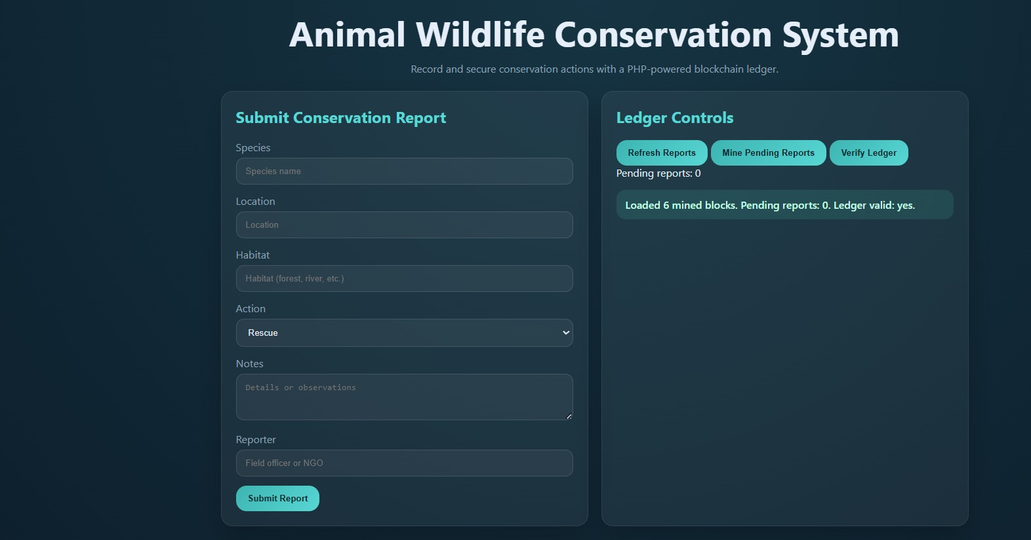

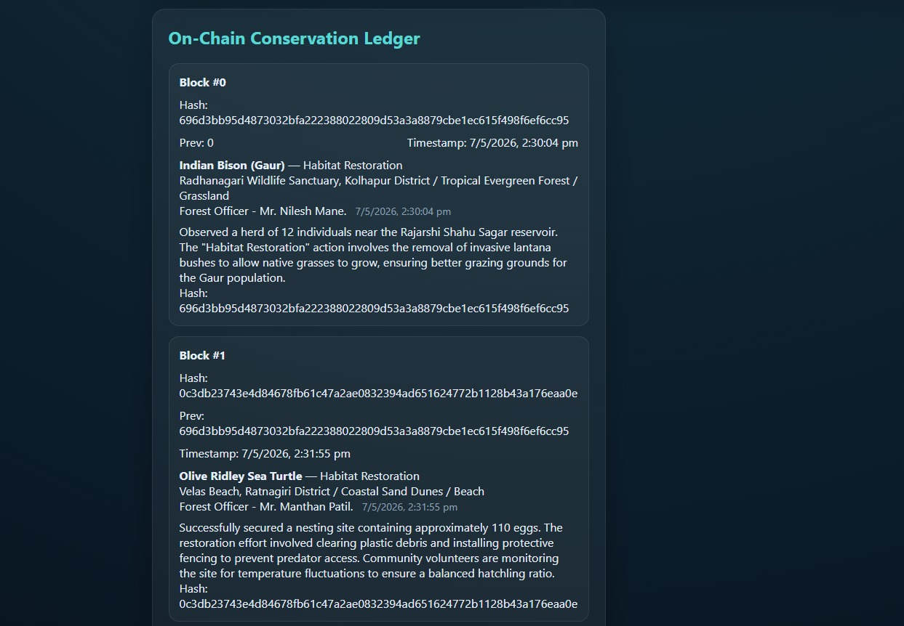

7. Conclusion
The “Animal Wildlife Conservation System” successfully demonstrates the implementation of blockchain concepts in wildlife conservation management. The system provides a secure, transparent, and efficient platform for recording and managing conservation activities such as animal rescue operations, habitat restoration, wildlife monitoring, and environmental protection initiatives.
The application allows authorized users to submit conservation reports, convert them into blockchain blocks, and verify ledger integrity using cryptographic hashing techniques. By linking blocks through previous hash values, the system ensures immutability and prevents unauthorized modification of conservation records.
The project effectively achieves its major objectives including secure data management, blockchain-based ledger maintenance, transparent record tracking, and verification of conservation data integrity. The user-friendly interface and structured workflow improve report handling and conservation activity management.
The system can be highly beneficial for forest departments, NGOs, wildlife researchers, and environmental organizations for maintaining reliable conservation records. Furthermore, the project provides a strong foundation for future enhancements such as cloud deployment, GPS integration, mobile applications, AI-based wildlife monitoring, and real decentralized blockchain implementation.
Overall, the project demonstrates how modern technologies like blockchain can be applied to solve real-world environmental and wildlife conservation challenges efficiently and securely.

8. References
- Satoshi Nakamoto, “Bitcoin: A Peer-to-Peer Electronic Cash System,” 2008.
- Ian Sommerville, Software Engineering, 10th Edition, Pearson Education.
- PHP Official Documentation.
- MySQL Official Documentation.
- MDN Web Documentation for HTML, CSS, and JavaScript.
- XAMPP Official Documentation.
- Blockchain Technology Research Papers and Online Journals.
- Wildlife Conservation Research Articles and Environmental Studies.
- W3Schools Web Development Tutorials.
- GeeksforGeeks PHP and Blockchain Concept Tutorials.
- Oracle MySQL Database Documentation.
- Research papers related to Blockchain-based Data Integrity Systems.
- Environmental Protection and Wildlife Management Research Publications.

